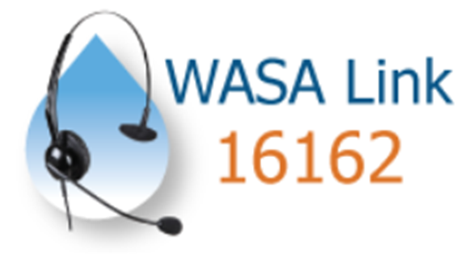

**Dhaka WASA Link Complain Center Manual**

Arif Fuad Rocky

Asst Manager,

DWASA Link Call Center

**Cell:** 01915867318, 01672118179

**DWASA Complain Center:**

Hotline number:16162(short code)/09611016162(long code).

Website: dwasa.complaincenter.com:16162

Dhaka WASA took an initiative to set up a complaint center to hear the problem regarding the services it offers to the population of Dhaka City. Now the consumers of Dhaka WASA can lodge a complaint just by.dialing 16162 (from banglalink & citycell) or 09611016162 from any operator serving in Bangladesh. People don't have to come to complaint center physically in their serving area anymore enabling them to save their valuable time and money spent in transportation

.

When customers call the complaint center and inform them of the problem along with the customer ID, the automated computer system can locate the problem area using the helpline center database linked with Dhaka WASA billing system. The computer system selects the responsible engineer for that particular location from the job card for every MODS zone which is pre configured in the computer system. The system then sends an SMS to the right person with the summary of the problem and exact location of the problem. Once the help center registers the complaint and initiates the ticket, the process operates on its own until the ticket for that complaint is closed thus ensuring that no problem remains untouched or unnoticed.

A customer can register complaints regarding Water & Sewerage, Billing, Drainage, Meter problems or just to have information about various services related to Dhaka WASA. Here we have to describe how the complaint center works related to the Water & Sewerage problem only.

**A Complaint Life Cycle of WATER.& SEWERAGE Problem**

**Hear the Problem**

* The call center agent receives complaints from customers and registers the customer account number/ bill number and the details of the problem into the computer system. The computer system generates a ticket number associated with that problem. At this stage the ticket given status 'New'

**Acknowledging the Problem**

* Once the ticket is generated, the computer system automatically selects the MODS zone, Engineers responsible to take care of the problem depending on the problem of the location. The computer system then sends alert SMS to the responsible SAE selected from the job card of that MODS Zone. The SMS contains information about the problem and a number to be dialed to acknowledge SAE has been aware of the problem. This number is also called 'Magic Number'. It's named so because if the number is dialed one will hear a busy tone but it's enough for the computer system to know that the problem is acknowledged or seen by the responsible SAE. Also the good news is it will not cost any money.
* At the same time, AE above the hierarchy of SAE will have a notification text SMS containing the information of the same problem, name of assigned SAE. The purpose of this SMS is just to let AE know about the problem and who is assigned to take care of the problem. The AE doesn't have to dial at this stage.

**SMS Templates:**

| **SMS to SAE** | **SMS to AE** |
| --- | --- |
| **Acknowledgment Alert SMS Template:** | **Acknowledgement Notify SMS Template:** |
| Plz ack ikt [_iktnum_] from [_callername__].C:_callernum_]  Add: [_calleraddress __]  Summ [_ ticketsummary __]  Dial: [_ anuman __] | Plz ack tkt [_tktnum __] from  [_ callername_]. C:L_callernum_]  Add: [_calleraddress __]  Summ: [_ticketsummary_]  Assig: [_assignec __] |

**Resolution of the Problem**

* Once the computer system receives the acknowledgment from the sać, the system immediately sends SAE and AE resolution text SMS respectively. The SMS that is sent to SAE will contain thanks for Acknowledging and request him to consult AE for updates. Once the assigned work is completed SAE will inform the AE about the final update of the problem just the same way as the job is usually done. This time SAE will not have to inform the computer system.
* On the other hand by the resolution SMS received by AE containing which problem ticket is acknowledged and by whom, the time of next SMS and a magic number. As the work is completed and informed by the SAE the AE will dial the magic number informing the system the work is completed. But there could be many problems that cannot resolve or solve in just 24 hrs. Some problem even takes many days depending on the nature of problem. The time to resolve the problem can easily expand from the dashboard by EE. For the best practice it is advice to increase the time of a particular problem within the first 24 hr.

| **SAE** | **AE** |
| --- | --- |
| **Res Alert SMS Template:** | **Res Notify SMS Template:** |
| Thnx for ack tkt [_ iktnum __] for  [_callername __]  Summ: [_ticketsummary __]  Stg: [_tktseq __]  Nxt SMS: aftr 24hrs  Consult AE for update | Tkt [_ tkinum __] was acknowledged for  [_callername__]  by [_ assignee __]  Stg: [_ tktseq __]  Nxt SMS: astr 24hrs  Dial [_magic number __]  __] Jif completed |

**Closing Stage:**

Once the work is completed the AE will inform the EE. The EE then closes the ticket from the dashboard.

**A complaint Life Cycle of WATER & SEWERAGE Problem.(Flow Chart)**



